
Subject: Programming with Java
ASSIGNMENT No : 28
TITLE: Develop a Java application demonstrating Remote Method Invocation (RMI) using stub and skeleton components for remote communication.

Name: Avdhoot Mohite Class: CSE A2
PRN: 25070122056 Batch:25-29

Problem Statement
Develop a Java application demonstrating Remote Method Invocation (RMI) using stub and skeleton components for remote communication.
Learning Objectives
To implement Remote Method Invocation for distributed Java applications.
Theory
Remote Method Invocation (RMI) is a Java technology that enables an object running on one Java Virtual Machine (JVM) to invoke methods of an object running on another JVM located on a different machine. RMI simplifies distributed application development by allowing remote objects to behave like local objects. It consists of remote interfaces, remote object implementations, the RMI registry, and client-server communication. The registry maintains references to remote objects, allowing clients to locate and invoke them. RMI provides platform-independent communication, object serialization, and automatic network handling, making it suitable for distributed enterprise applications.
Exercise
- Create a remote calculator service using Java RMI

- import java.rmi.Remote;
- import java.rmi.RemoteException;

- public interface assignment28a extends Remote {
- int add(int a, int b) throws RemoteException;
- int subtract(int a, int b) throws RemoteException;
- int multiply(int a, int b) throws RemoteException;
- double divide(int a, int b) throws RemoteException;
- }

SERVER:

import java.rmi.*;
import java.rmi.registry.*;
import java.rmi.server.*;

public class assignment28a_server extends UnicastRemoteObject
implements assignment28a {

public assignment28a_server() throws RemoteException {
super();
}

public int add(int a, int b) {
return a + b;
}

public int subtract(int a, int b) {
return a - b;
}

public int multiply(int a, int b) {
return a * b;
}

public double divide(int a, int b) throws RemoteException {
if (b == 0) {
throw new RemoteException("Division by zero is not allowed");
}
return (double) a / b;
}

public static void main(String[] args) {
try {
LocateRegistry.createRegistry(1099);

assignment28a_server obj = new assignment28a_server();

Naming.rebind("rmi://localhost:1099/Calculator", obj);

System.out.println("Calculator RMI Server is running...");

} catch (Exception e) {
System.out.println("Server Error: " + e.getMessage());
}
}
}

Client:

import java.rmi.*;
import java.util.Scanner;

public class assignment28a_client {
public static void main(String[] args) {

try {
assignment28a obj = (assignment28a)
Naming.lookup("rmi://localhost:1099/Calculator");

Scanner sc = new Scanner(System.in);

System.out.print("Enter first number: ");
int a = sc.nextInt();

System.out.print("Enter second number: ");
int b = sc.nextInt();

System.out.println("Addition: " + obj.add(a, b));
System.out.println("Subtraction: " + obj.subtract(a, b));
System.out.println("Multiplication: " + obj.multiply(a, b));

if (b != 0) {
System.out.println("Division: " + obj.divide(a, b));
} else {
System.out.println("Division not possible (zero divisor)");
}

sc.close();

} catch (Exception e) {
System.out.println("Client Error: " + e.getMessage());
}
}
}

OUTPUT:
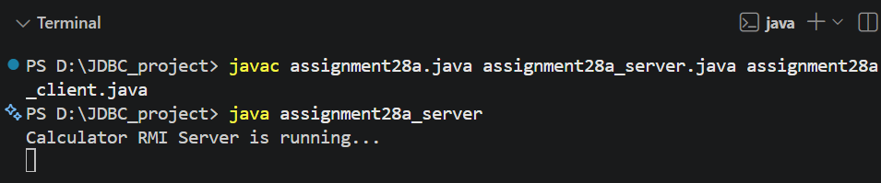
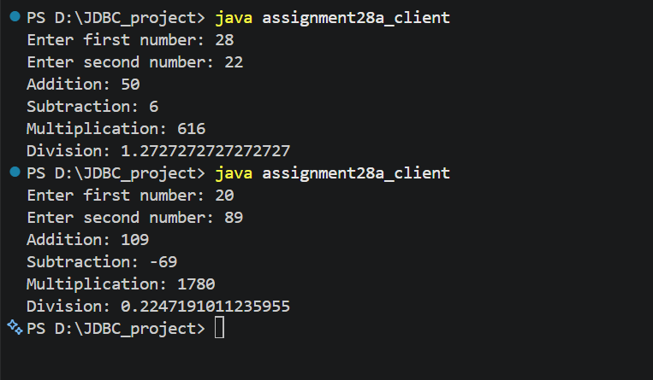

2. Create a Java application using RMI where the server converts temperature values between Celsius and Fahrenheit. The client sends input temperature and receives converted output.
REMOTE:
import java.rmi.Remote;
import java.rmi.RemoteException;

public interface assignment28b extends Remote {
double celsiusToFahrenheit(double c) throws RemoteException;
double fahrenheitToCelsius(double f) throws RemoteException;
}

SERVER:

import java.rmi.*;
import java.rmi.registry.*;
import java.rmi.server.*;

public class assignment28b_server extends UnicastRemoteObject
implements assignment28b {

public assignment28b_server() throws RemoteException {
super();
}

public double celsiusToFahrenheit(double c) {
return (c * 9 / 5) + 32;
}

public double fahrenheitToCelsius(double f) {
return (f - 32) * 5 / 9;
}

public static void main(String[] args) {
try {
LocateRegistry.createRegistry(1100);

assignment28b_server obj = new assignment28b_server();

Naming.rebind("rmi://localhost:1100/Temperature", obj);

System.out.println("Temperature RMI Server is running...");

} catch (Exception e) {
System.out.println("Server Error: " + e.getMessage());
}
}
}

Client:

import java.rmi.*;
import java.util.Scanner;

public class assignment28b_client {
public static void main(String[] args) {

try {
assignment28b obj = (assignment28b)
Naming.lookup("rmi://localhost:1100/Temperature");

Scanner sc = new Scanner(System.in);

System.out.println("1. Celsius to Fahrenheit");
System.out.println("2. Fahrenheit to Celsius");

System.out.print("Enter choice: ");
int choice = sc.nextInt();

System.out.print("Enter temperature: ");
double temp = sc.nextDouble();

if (choice == 1) {
System.out.println("Fahrenheit: " +
obj.celsiusToFahrenheit(temp));
} else if (choice == 2) {
System.out.println("Celsius: " +
obj.fahrenheitToCelsius(temp));
} else {
System.out.println("Invalid choice!");
}

sc.close();

} catch (Exception e) {
System.out.println("Client Error: " + e.getMessage());
}
}
}

OUTPUT:
